The store will have to cover three separate elements of the game

* Spending real money on premium currency(ies)
* Spending Faith on the Gacha mechanic
* Spending premium currency on in-game items

I wanted to create a premium currency purchasing mechanic like this one:

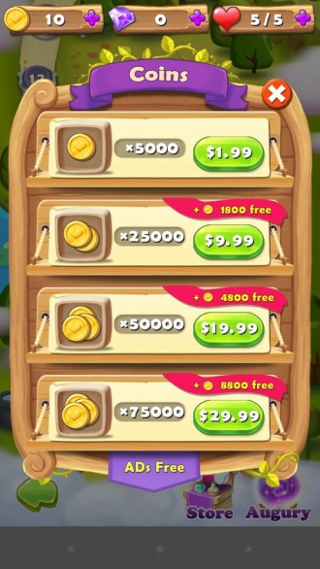

Mariana D'Ornellas. (NA). *Screenshot_2015-12-1.* Available: https://www.pinterest.co.uk/pin/358388082831405136/. Last accessed 28/11/2017.

And to have a list of items to be browsed or bought like this one:

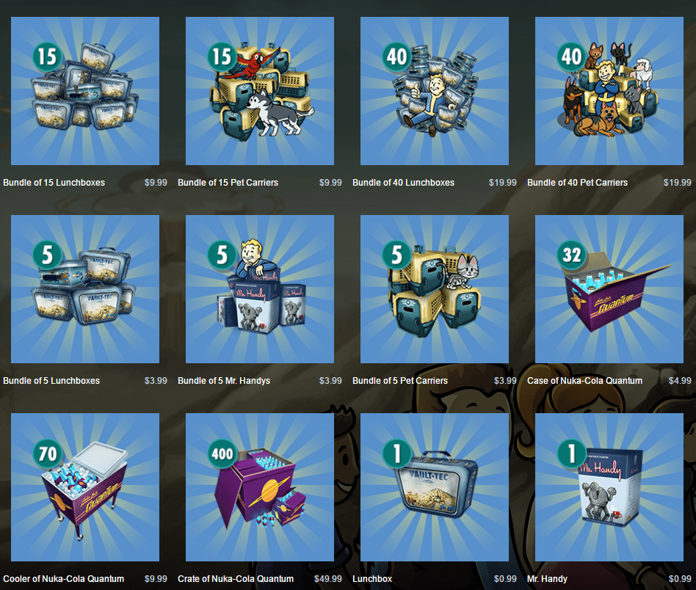

techatz. (NA). *FALLOUT SHELTER IS NOW AVAILABLE FOR PC THROUGH STEAM; SOME FANS AREN’T HAPPY.* Available: http://www.techatz.com/news/fallout-shelter-now-available-pc-steam-fans-arent-happy/. Last accessed 28/11/2017.

I am trailing having all the elements on one game screen but if this is too much for the player to handle then the different elements,

* Gacha
* Premium currency buying
* Item buying/browsing

Could all be on different screens pop-ups

To get to the store the store icon will be present on the game screen. Pressing that button will bring you to this screen:

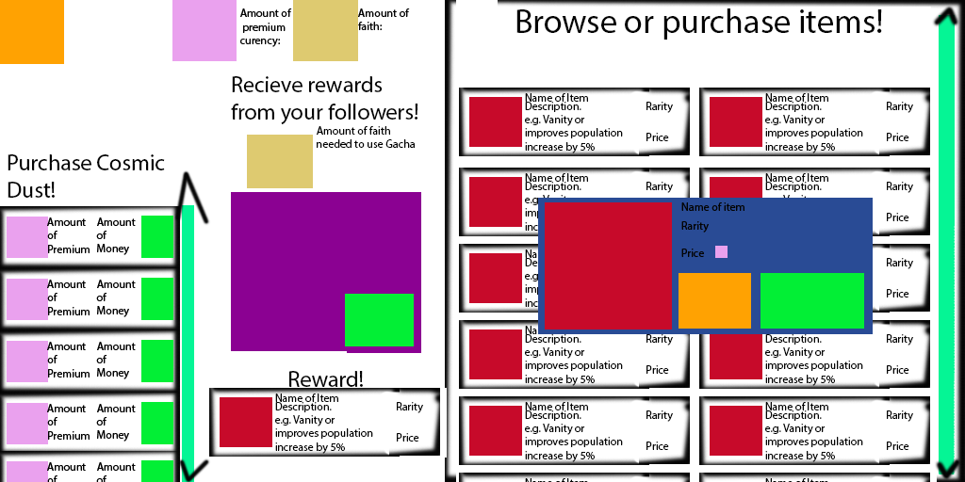

Key:

Orange: Back/Cancel Button

Pink: Premium Currency Icon

Green: Make transaction button

Red: Image of item

Beige: Faith Icon

Purple: Gacha Icon

Interaction

Players can scroll the Item list and premium currency list to see more listings.

Selecting the Make transaction button will try to make the transaction happen

Selecting an item from the browsing list brings up the blue pop-up

Selecting the back/cancel button on the blue pop-up makes it go away

Selecting the make transaction button on the blue pop-up attempts to make the transaction and makes the pop-up go away

Selecting the Make transaction button on the gacha attempts to use the player faith and deposits an item below in the reward area which is given to the player

The reward slot is empty when a player enters the store and will be overwritten by additional rewards the player gets from the gacha if they do not leave the store screen in between (although of course the player will then have access to all items)

Selecting the back button on the main store UI brings the player back to the game screen